1.What is SDLC ?

* SDLC Software Development Life Cycle.
* SDLC is series of steps that provide model for development.

2.Wht is software Testing ?

* Software testing is process used to identify correctness, completeness, quality of developed computer software.

3.What is agile methodology ?

* Agile means delivering software working in small parts with continuous feedback and improvement.

4.What is SRS ?

* SRS Software Requirement specification.
* SRS is complete description of the behaviour of the system to be developed.it includes set of use cases that describes all of the interaction that the users with the software.

5.What is OOPs.

* Object Oriented Programming.
* To way to write code and it provide less code redundancy with more security.

6.Write basics concept of OOPs.

* Concepts of OOPs :

1.Class

2.Object

3.Inheritance

4.Encapsulation

5.Polymorphism

6.Abstraction

7.What is object.

* Object gives permission to access functionality of class.

8.what is class.

* It is collection of data member and member function.

9.What is encapsulation.

* Wrapping of data.

10.What is inheritance.

* To derive attribute of some other class.

11.What is polymorphism.

* One name multiple form.

12. Write SDLC phases with basic introduction.

* SDLC phases:
* Requirement gathering and Analysis
* Designing
* Implementation
* Testing
* Deployement
* Maintenance

1.Requirement gathering

* Collect details from client about the project like functional requirement and non functional requirement.
* Functional requirement:
* Features
* UI requirement
* Functionality of the feature
* Non-functional requirement:
* Performance
* Security
* Usability

2.Analysis

* To analyze the requirement and convert the crs into srs

3.Design

* To prepare Design/UI as per the requirements

4.Implementation

* Coding

5.Testing and Deplyoment

* To verify the correctness ,completeness and quality of the software developed and deploy it.

6.Maintains

* Corrective : to repair a defect
* Adaptive : to test in new platform
* Perfective : to add a new feature

13. Explain Phases of the waterfall model.

* Requirement gathering
* Analysis
* Designing
* Implementation
* Testing
* Deployment
* Maintenance

14. Write phases of spiral model.

* Planning
* Risk analysis
* Engineering
* Customer evaluation

15. Write agile manifesto principles.

* Frequent delivery of working software
* Simplicity
* Support, trust and motivate the people involved
* Face to face interaction
* Collaboration between business stackholders and developers
* Self-organizing team encourage great architecture , requirement and designs

16. Explain working methodology of agile model and also write pros and cons.

* It is like incremental model which used to dived working software into small parts and give the continuous feedback and improvement.
* Pros:
* Teamwork and cross training.
* Resource requirement are less.
* Changing requirement during developing.
* Cons:
* Not suitable for complex software.
* Strict delivery management.
* Depends heavily on customer , if customer is not clear then developer team goes on wrong way.

17. Draw Use-case on online bill payment system ( paytm ) .

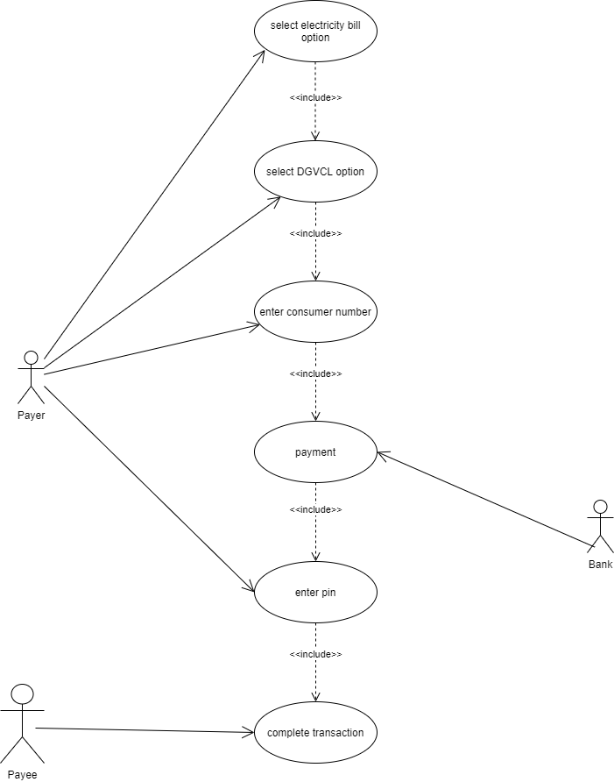

18. Draw Use-case on banking system for customers.

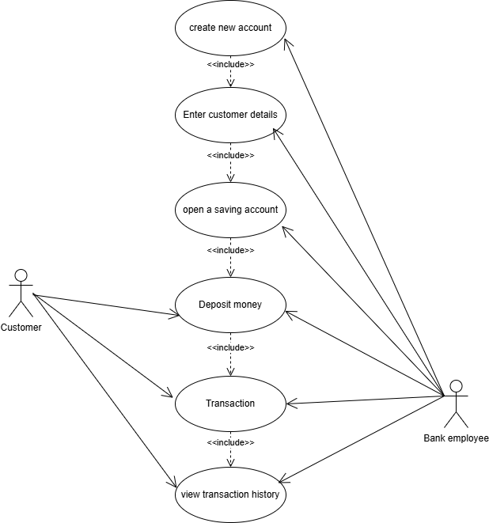

19.Draw Use-case on Broadcasting System.

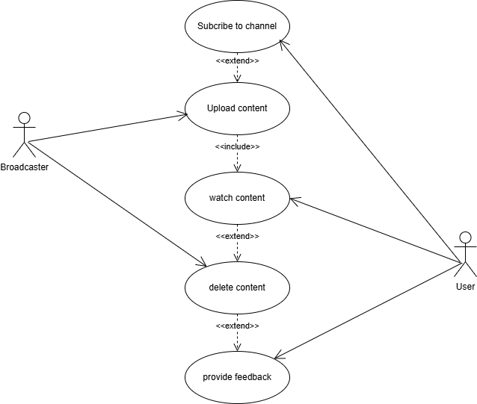

20.Draw use-case on OTT Platform.

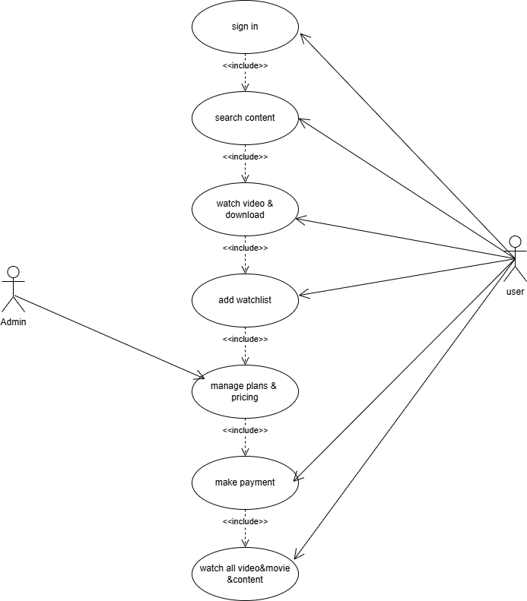

21. Draw use-case on E-commerce application.

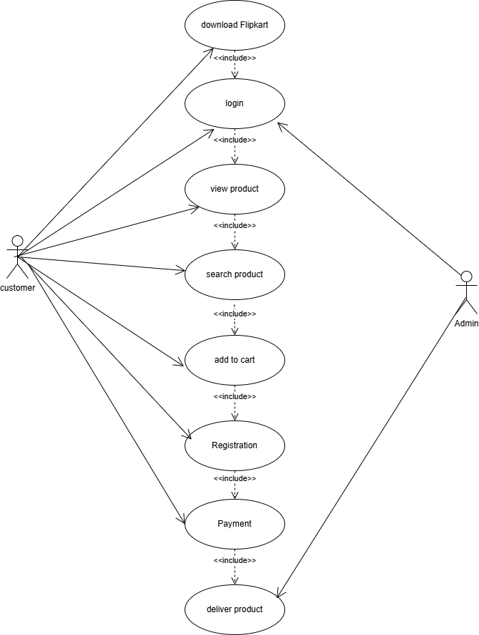

22. Draw use-case on Online shopping product using payment gateway.

